Introduction
Welcome Back to your favorite Programming Lab students. In this lab manual, we shall work together to learn and implement new programming concepts.

Skills to be learned:
- Declare and initialize arrays of different data types.

Let's do some coding.

Skill: Declare and initialize arrays of different data types.

Introduction

By this week, you have learned how to write a program that contains loops, and conditional structures. In this class, we will learn about another very powerful concept known as Arrays.

An array is a collection of similar data items stored at contiguous memory locations and elements that can be accessed using the indices of an array.
Following are the types of arrays that are often used in programs.
- Integer arrays
- Float arrays
- Char arrays
- String arrays

Consider a task in which you want to store the mid-term marks of Programming Fundamentals of 200 students. Let's create an Array to store the marks of 200 students of the Computer Science Department of UET Lahore.

Array Declaration
Following is the Syntax of an Array  dataType ArrayName[size]; | For example,  int marks[200];
This C++ statement will declare an array of size in the memory of the computer. Now, we can use the indices of the array to store the marks of the students at different addresses.

Index of Array
An array is a collection of items on contiguous memory locations. Every item in the array exists on a unique address in memory. Consider the following diagram for a better understanding.

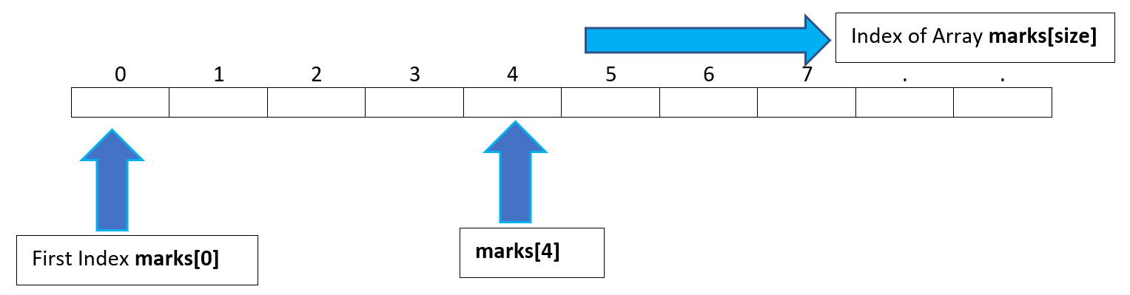
We can use the assignment operator to assign a value using the index of the array item.

Consider the following program for better understanding

Task 01(WP): Write a program that declares an array of 5 integer elements, initializes them one by one and displays them.
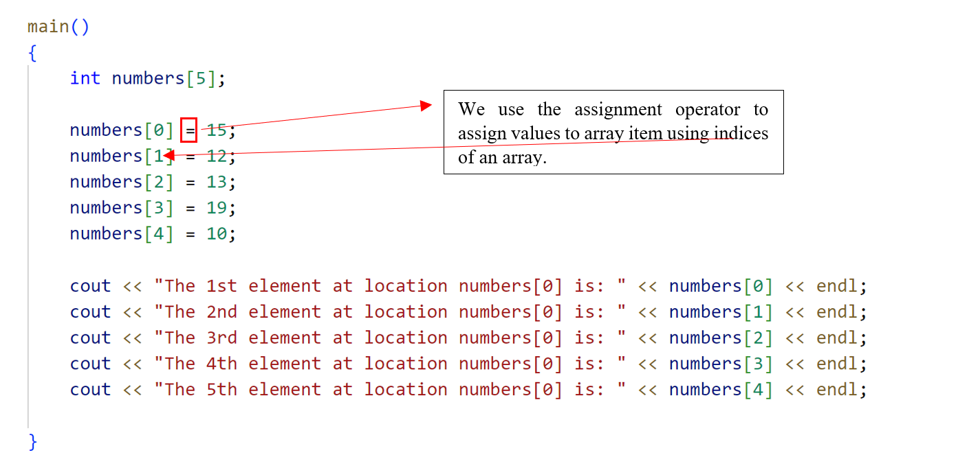
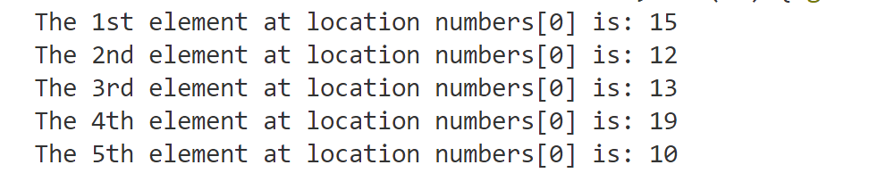

Task 02(CA): Write a program that declares an array of 5 elements, initializes them one by one and displays only the 2nd and 4th elements of an array.

Similarly, we can store the value entered by the user in the array by using the following statement.
cin >> arrayName[index];

Task 03(WP): Write a program that declares an array of 5 elements, initializes them one by one by user input, and displays 1st and last elements of the array.
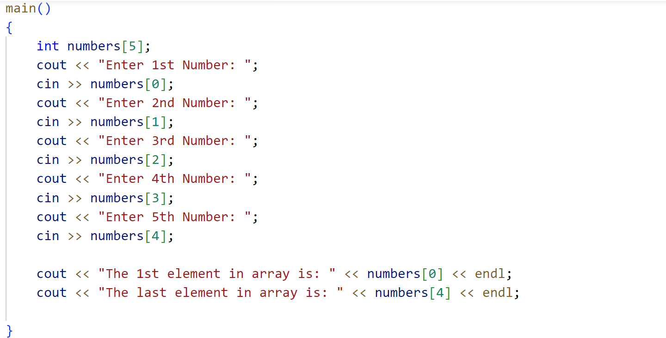
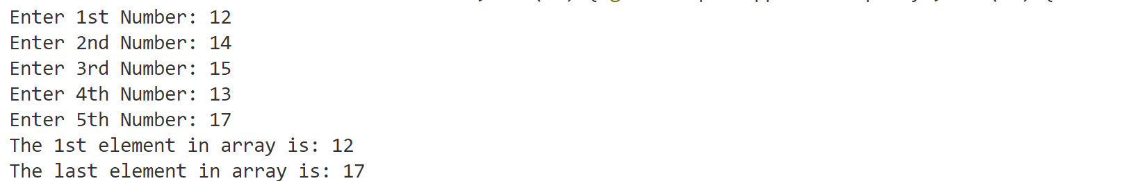

🚧 Problem 🚧
We have used the same variable name to store multiple values but our code is repeating for taking input.
Is there any better way ❓

💡 Solution 💡
We can use the counting loop for taking input in the array from the user

Consider the same question with loops below.

Task 04(WP): Write a program that declares an array of 5 elements, initialize them one by one by user input and display 1st and last elements of the array.
Instruction: Use a loop for taking input from the user
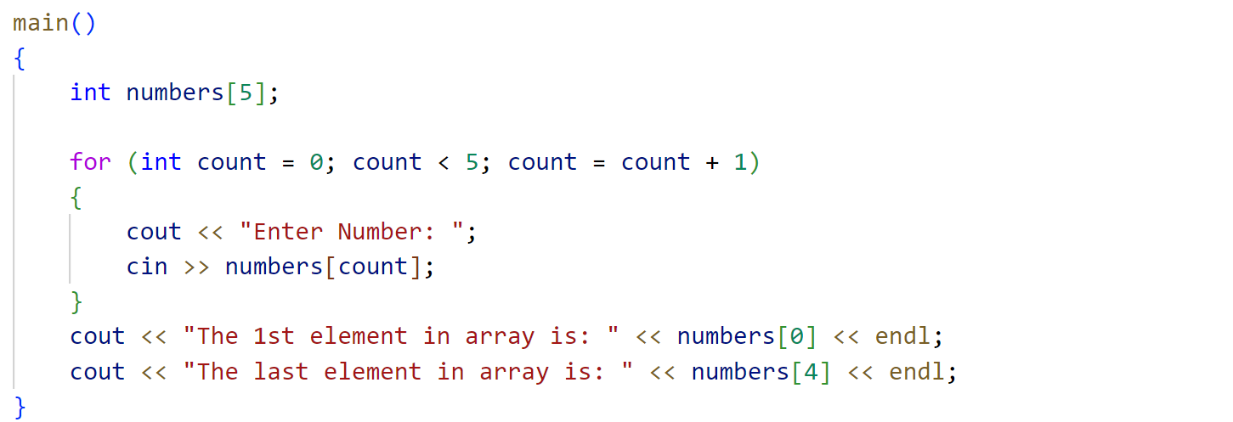


Task 05(OP): Write a program that takes n numbers from the user, stores them in an array, and displays those numbers on the screen.
Instruction: First of all the user will tell how many numbers he/she wants to enter. Then take those numbers as input from the user and store them in the array.
Similarly, we can use the array for solving more complex problems.
Consider the following task for better understanding.

Task 06(CL): Write a program that prints the sum and average of the first 5 natural numbers on the screen.
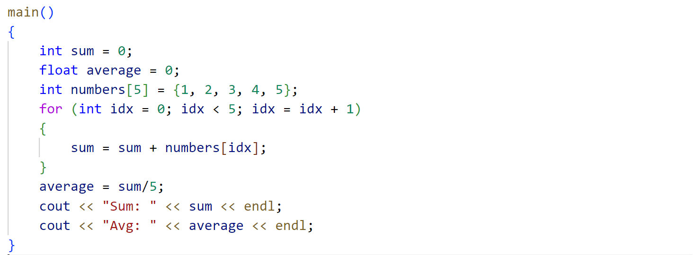

String as Character Array
String values are stored as a character array inside memory and the end of the string is stored as ‘\0’ referred to as a null character.

Consider the following task for better understanding.
Task 07(WP): Write a program that prints whether a specific character is present in a string or not.
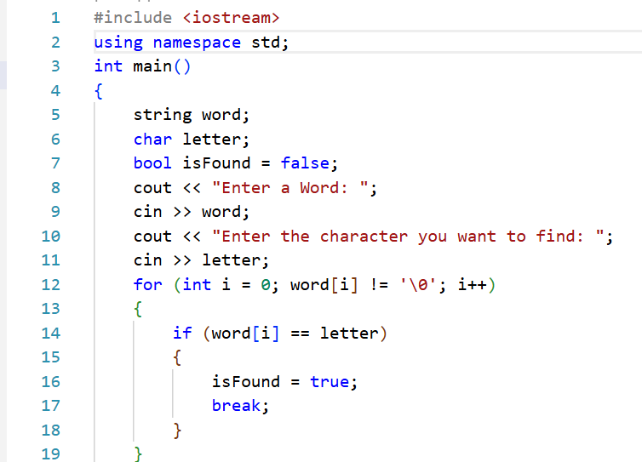 | 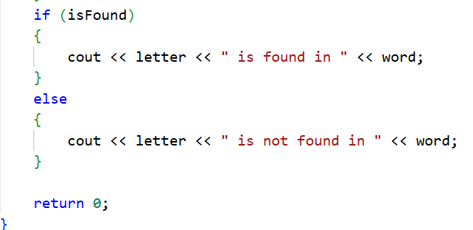
Point to ponder:
We have used a counter loop in the check function.
Did you already knew how many times we had to iterate the loop..??
Which loop would be better in this case?

Consider the following amazing facts about the string variables.

Do you know? 💡
You can use the getline(cin, stringVariableName) function to take string input that includes a space character.

Do you know? 💡
You can declare a string by using any of the following methods. Pretty cool, isn’t ?
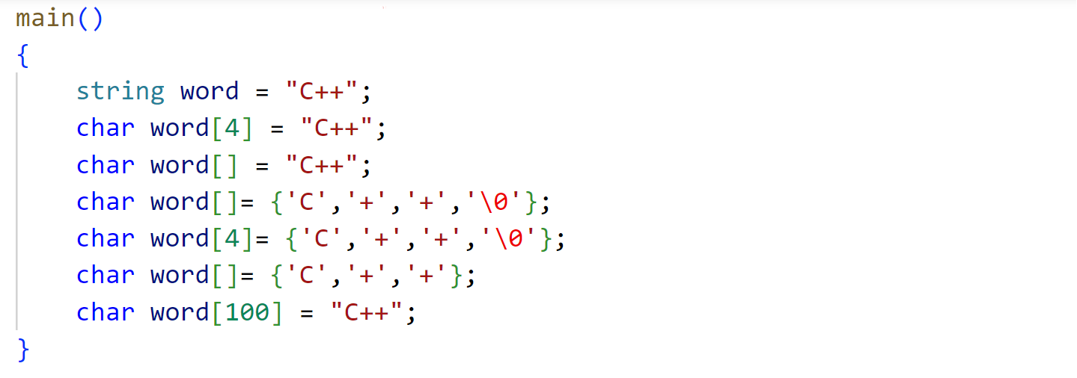

Task 01(OP): (Word Postmortem)
Write a program that takes a word from the user and stores it in a character array and displays the location of all alphabets in the array.
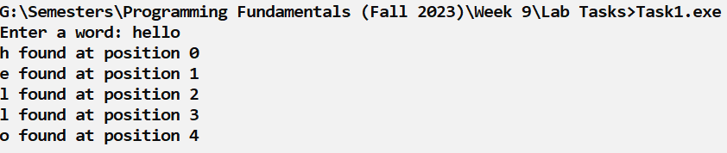

Task 02(OP): (Reverse Word)
Write a program that takes a string as input parameter and displays it in reverse order.

Task 03(OP): (Next Letter)
Write a C++ program to change every letter in a given string with the letter following it in the alphabet (ie. a becomes b, p becomes q, z becomes a).
For Example:
Input: aslam
Output: btmbn

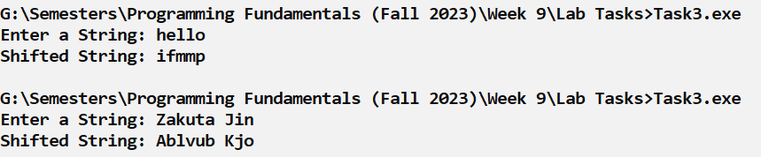
Hint for solving this problem in an easy way:
ASCII (American Standard Code for Information Interchange) codes in C++ refer to the numeric representations of characters in the ASCII character set. The ASCII character set includes various characters, such as letters, digits, punctuation marks, and control characters, each of which is assigned a unique numerical value.
In C++, you can obtain the ASCII code of a character by storing it in an int variable. Here's a simple example:

char character = 'A'; // Change this to the character you want to find ASCII code for
int asciiCode = character;

cout << "The ASCII code for " << character << " is " << asciiCode;

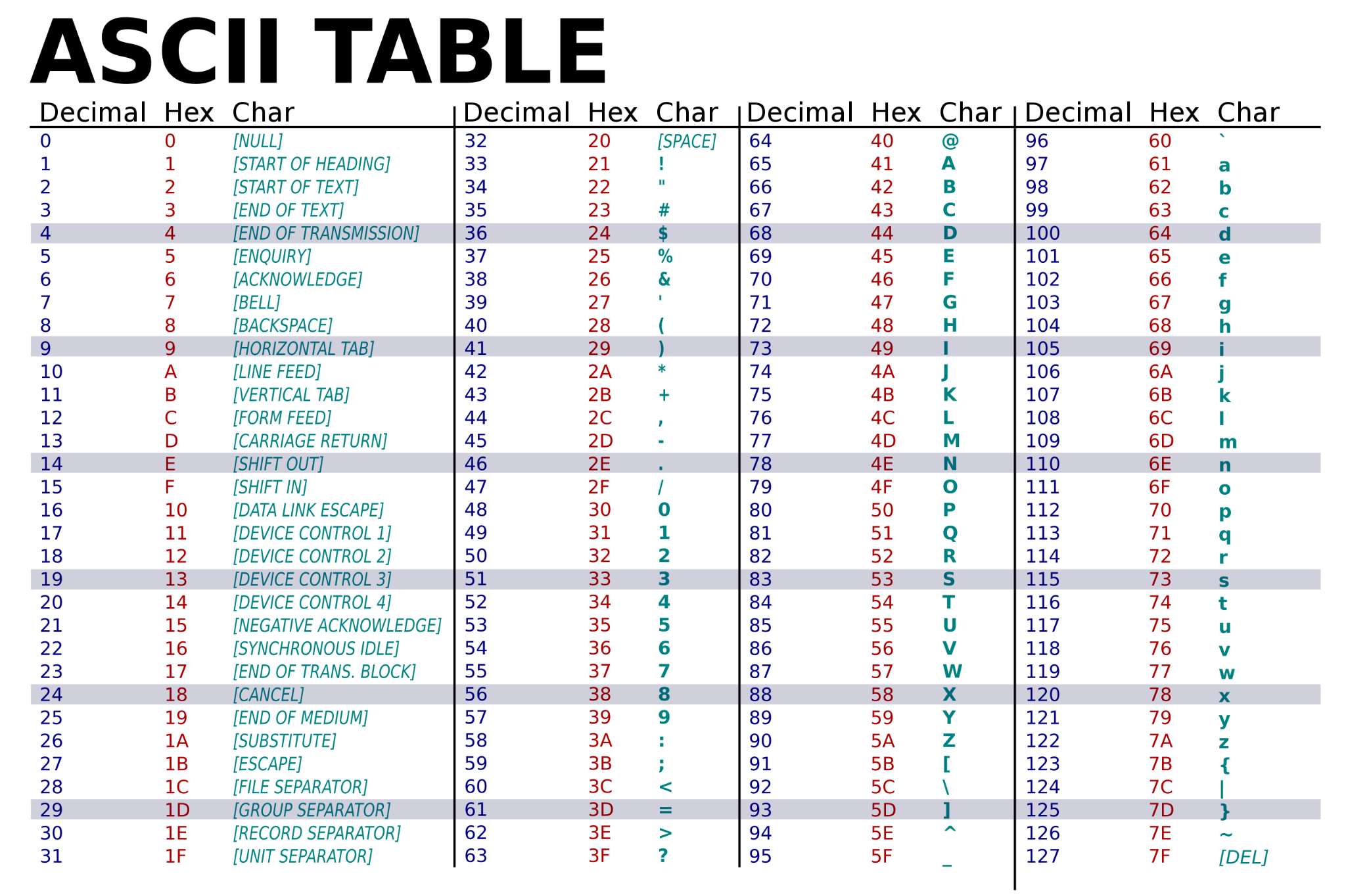
Ignore the Hex column, just consider the Decimal and Char column.

Task 04(OP): (Reverse Numbers)
Write a program that takes n numbers from the user, stores them in an array, and prints them in reverse order.

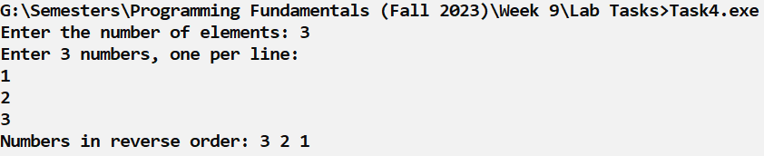
Solution:
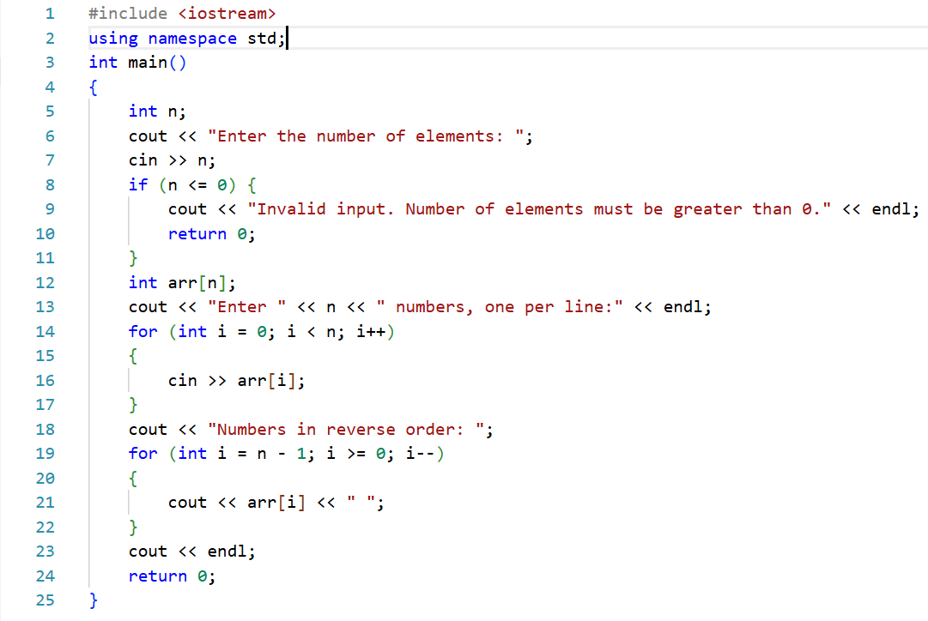

Task 05(OP): (Validate Input)
Write a program that takes n numbers from the user and stores them in an array.
The program should print “Already Entered” if the user has already entered that number.

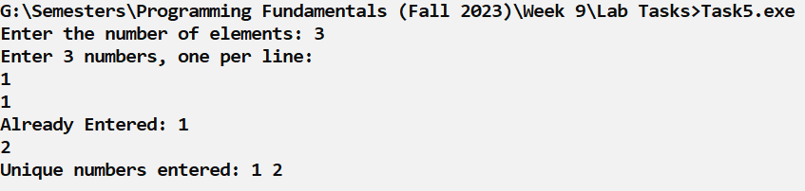

Task 06(OP): (Find Largest)
Write a program that takes n numbers from the user and stores them in an array and display largest number entered by the user.

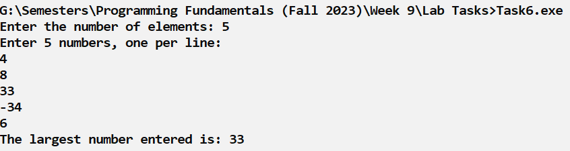

Task 07(CP): (Resistors)
When resistors are connected together in series, the same current passes through each resistor in the chain and the total resistance, RT, of the circuit must be equal to the sum of all the individual resistors added together. That is
RT = R1 + R2 + R3 ...
Create a program that takes an array of values resistance that are connected in series, and calculates the total resistance of the circuit in ohms. The ohm is the standard unit of electrical resistance in the International System of Units ( SI ).
Test Cases:
[1, 5, 6, 3] ➞ "15"
[16, 3.5, 6] ➞ "25.5"
[0.5, 0.5] ➞ "1.0"

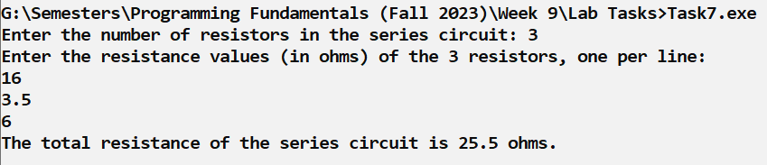

Task 08(CP): (Insert Array in Middle)
Create a program that takes two arrays and inserts the second array in the middle of the first array. The first array always has two elements.

Test Cases:
[1, 10], [2, 3, 4, 5, 6, 7, 8, 9] ➞ [1, 2, 3, 4, 5, 6, 7, 8, 9, 10]
[15,150], [45, 75, 35] ➞ [15, 45, 75, 35, 150]

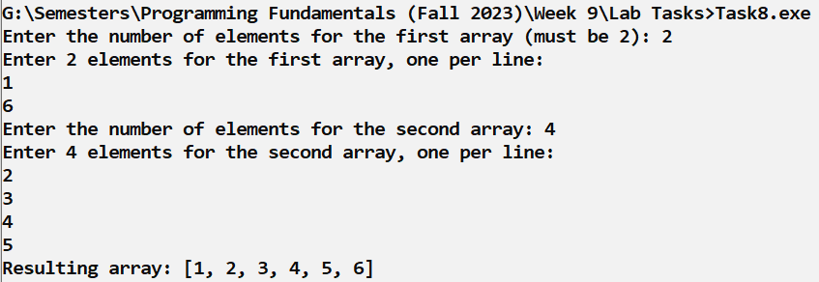

Task 09(CP): (Pay the Bill)
Given a total due and an array representing the amount of change in your pocket, determine whether or not you are able to pay for the item. The change will always be represented in the following order: quarters, dimes, nickels, and pennies.
[25, 20, 5, 0], 4.25 should yield true, since having 25 quarters, 20 dimes, 5 nickels, and 0 pennies gives you 6.25 + 2 + .25 + 0 = 8.50.
NOTE:
- quarter: 25 cents / $0.25
- dime: 10 cents / $0.10
- nickel: 5 cents / $0.05
- penny: 1 cent / $0.01
Test Cases:
[2, 100, 0, 0], 14.11 ➞ false
[0, 0, 20, 5], 0.75 ➞ true
[30, 40, 20, 5], 12.55 ➞ true
[10, 0, 0, 50], 3.85 ➞ false
[1, 0, 5, 219], 19.99 ➞ false

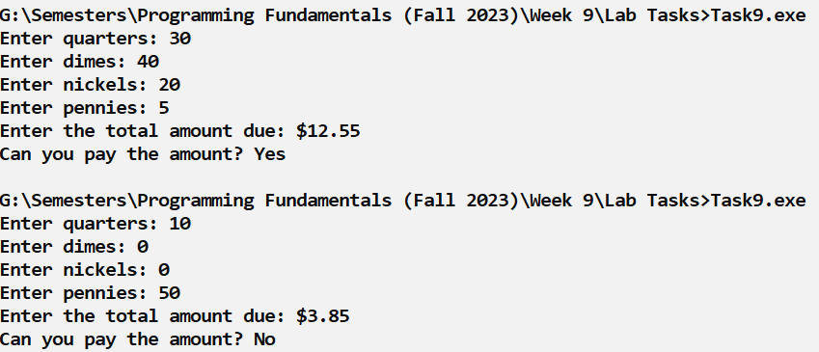

Task 10(CP): (Something)
Write a program that prints the string "something" joined with a space " " and the given argument a.
Test Cases:
"is better than nothing" ➞ "something is better than nothing"
"Bob Jane" ➞ "something Bob Jane"
"something" ➞ "something something"

Task 11(CP): (Vowels Removed)
Create a program that takes a string and returns a new string with all vowels removed.
Test Cases:
Input:
"I have never seen a thin person drinking Diet Coke."
Output:
" hv nvr sn thn prsn drnkng Dt Ck."

Task 12(CP): (Special Array or Not)
An array is special if every even index contains an even number and every odd index contains an odd number and display true if an array is special, and false otherwise.
Examples
isSpecialArray([2, 7, 4, 9, 6, 1, 6, 3]) ➞ true
// Even indices: [2, 4, 6, 6]; Odd indices: [7, 9, 1, 3]

isSpecialArray([2, 7, 9, 1, 6, 1, 6, 3]) ➞ false
// Index 2 has an odd number 9.

isSpecialArray([2, 7, 8, 8, 6, 1, 6, 3]) ➞ false
// Index 3 has an even number 8.
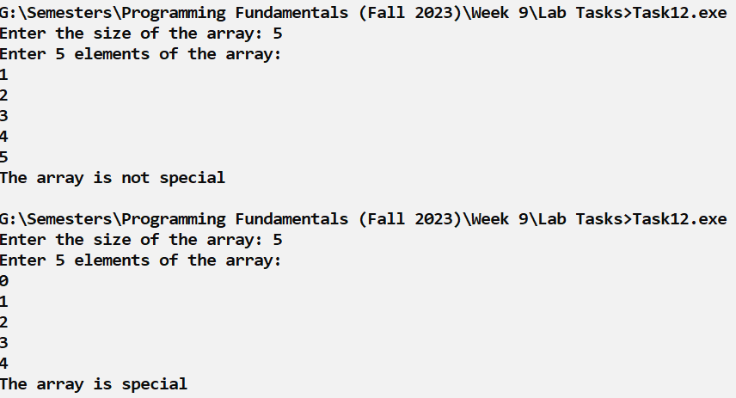

Task 13(CP): (Jazzify)
Create a program which concatenates the number 7 to the end of every chord in an array. Ignore all chords which already end with 7.

Examples
jazzify(["G", "F", "C"]) ➞ ["G7", "F7", "C7"]

jazzify(["Dm", "G", "E", "A"]) ➞ ["Dm7", "G7", "E7", "A7"]

jazzify(["F7", "E7", "A7", "Ab7", "Gm7", "C7"]) ➞ ["F7", "E7", "A7", "Ab7", "Gm7", "C7"]

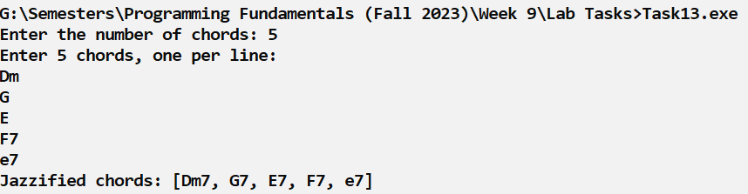
Use of Array in Business Applications:
Arrays are used in business applications to store and manage multiple related data values in a single variable. For example, a company can use an array to store the daily sales of a week, employee salaries, product prices, or customer IDs. This helps businesses organize data easily, process information quickly, and perform calculations such as totals or averages efficiently. Arrays make programs simpler and more effective when dealing with a large amount of business data.
Example #1:
Write a C++ program to simulate a simple ATM Management System using basic programming concepts.
Requirements
- The program should allow the user 3 attempts to enter the ATM PIN using a for loop.
- The correct PIN is 1234.
- The entered PINs should be stored in an array.
- If the correct PIN is entered using a logical operator (==), the program should display “Login Successful” and show the ATM menu.
- After successful login, display the following options:
- 1 → Check Balance
- 2 → Deposit Money
- 3 → Withdraw Money
- 4 → Exit
- If the user selects Check Balance, the program should display the current account balance.
- If the user selects Deposit Money, the program should ask for an amount and add it to the balance.
- If the user selects Withdraw Money, the program should ask for an amount and deduct it from the balance only if sufficient balance is available.
- If the balance is insufficient, display “Insufficient Balance”.
- If the user selects Exit, the program should terminate.
The program must use:
- Array
- if–else statements
- logical operators (&&, ||)
- for loop
Code
#include <iostream>
using namespace std;
int main(){
int correctPIN = 1234;
int pin[3]; // Array to store PIN attempts
int choice;
int balance = 1000; // Initial balance
int amount;
bool login = false;
// PIN attempts using for loop
for(int i = 0; i < 3; i++)
{
cout << "Enter ATM PIN: ";
cin >> pin[i];
if(pin[i] == correctPIN)
{
login = true;
cout << "Login Successful\n";
break;
}
else
{
cout << "Incorrect PIN\n";
}
}
// If login successful
if(login == true)
{
while(true)
{
cout << "\n--- ATM Menu ---\n";
cout << "1. Check Balance\n";
cout << "2. Deposit Money\n";
cout << "3. Withdraw Money\n";
cout << "4. Exit\n";
cout << "Enter your choice: ";
cin >> choice;
if(choice == 1)
{
cout << "Current Balance: " << balance << endl;
}
else if(choice == 2)
{
cout << "Enter amount to deposit: ";
cin >> amount;
balance = balance + amount;
cout << "Updated Balance: " << balance << endl;
}
else if(choice == 3)
{
cout << "Enter amount to withdraw: ";
cin >> amount;

if(amount <= balance && amount > 0)
{
balance = balance - amount;
cout << "Remaining Balance: " << balance << endl;
}
else
{
cout << "Insufficient Balance\n";
}
}
else if(choice == 4)
{
cout << "Thank you for using ATM\n";
break; // Exit the loop
}
else
{
cout << "Invalid Choice\n";
} }
else
{
cout << "Too many incorrect attempts. Access Denied.\n"; }
return 0;
}
Challenging Problem #6:
Write a C++ program to create a simple University Management System using basic programming concepts.
Requirements
- The program should allow the user 3 login attempts using a for loop.
- The correct login credentials are:
  - Username: admin
  - Password: 1234
- The entered usernames should be stored in an array.
- If the username and password are correct using a logical operator (&&), the program should display "Login Successful" and show the main menu.
- After successful login, display the following menu:
- 1 → Add Student
- 2 → View Students
- 3 → Add Course
- 4 → View Courses
- 5 → Exit
- When the user selects Add Student, the program should ask for student name and age and store them in arrays. The system should allow multiple students (up to 3).
- When the user selects View Students, the program should display all stored student information from the arrays.
- When the user selects Add Course, the program should ask for course name and store it in an array. The system should allow multiple courses (up to 3).
- When the user selects View Courses, the program should display all stored courses.
- If the user selects Exit, the program should terminate.
The program must use:
- Arrays
- if–else statements
- logical operators (&&, ||, !)
- for loop

Test Case:
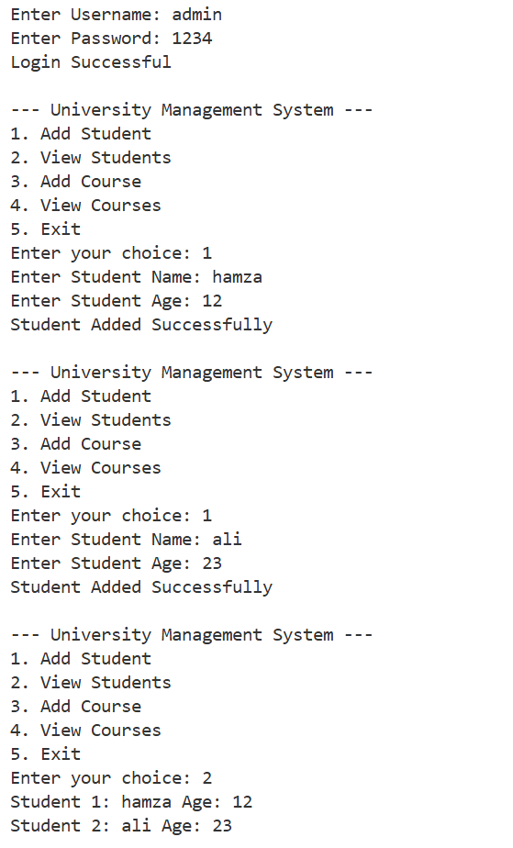

Good Luck and Best Wishes !!
Happy Coding ahead :)

